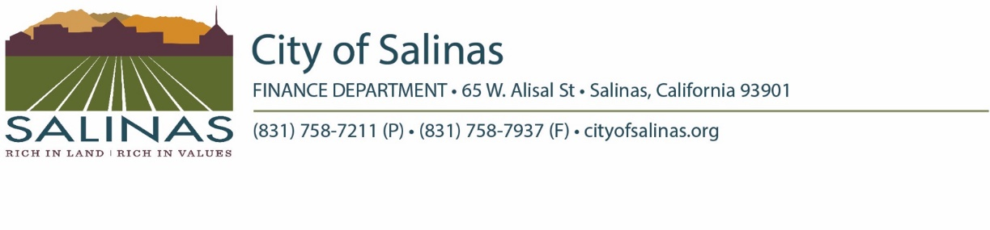

City of Salinas

Request for Unclaimed Monies

Pursuant to California Government Code Section 50052, the undersigned is filing a claim for previously unclaimed money.

The undersigned claimant certifies, under penalty of perjury, that:

* The claimant is the owner of said unclaimed monies and the person entitled to receive the monies set forth in the claim;
* The check/warrant was not endorsed and has not been paid, transferred, or lawfully seized;
* The claimant cannot reasonably obtain possession of the check/warrant because it was lost, destroyed or mutilated, its whereabouts cannot be determined, or it is in the wrongful possessions of an unknown person or a person that cannot be found or is not amenable to service of process, in any event, before that same was paid by the City of Salinas, and the check/warrant cannot now be produced by the claimant.

Further, the claimant acknowledges and understands the City of Salinas will cancel the City check/warrant referenced below, causing it to be non-negotiable, when a replacement check/warrant is issued, and the claimant agrees to indemnify and hold harmless the City of Salinas, its officers, and employees from any loss resulting from the payment of said claim.

|  |  |
| --- | --- |
| **Check/Warrant Number** | **Amount** |
|  |  |

**Claimant must sign this affirmation, or the claim will be rejected.**

|  |  |  |  |  |
| --- | --- | --- | --- | --- |
| **Full Name or Business Name** | | **Social Security or Tax ID No.** | | |
|  | |  | | |
| **Street Address** | **City** | **State/Prov** | **Zip Code** | **Country** |
|  |  |  |  |  |
| **Signature** | **Date** | **Phone Number** | | |
|  |  |  | | |

S**ignature must be notarized, if claim amount is greater than $1,000.**

Subscribed and sworn before me this ________day of ___________________year of ____________.

_______________________________________________________

Notory Public in and for

The County of _____________________, State of ________________________

Remit completed and signed affirmation to:

Accounts Payable, Department of Finance, City of Salinas, 200 Lincoln Avenue, Salinas, CA 93901

**For Finance Department**

**Proof of Identity Verified (check one):**

Driver’s License _____ State Issued Identification Card ___________

Verified By:___________________________________ Date:___________________

**Claim Approval/Rejection**

Claim: Approved Rejected

Reason for Rejection: ________________________________________________________

Reviewed By: _______________________________________ Date:________________